True or False: Functions should abide by the single entry single exit principle

**TRUE**

What does it mean for a module to exhibit low coupling?

**It relies very little on other modules**

Should a module be highly or lowly coupled?

**Lowly**

What does it mean for a module to exhibit low cohesion?

**It performs many tasks**

Should a module be highly or lowly cohesive?

**Highly**

What should a pointer variable be set to before it is given an address?

**NULL**

More questions on next page

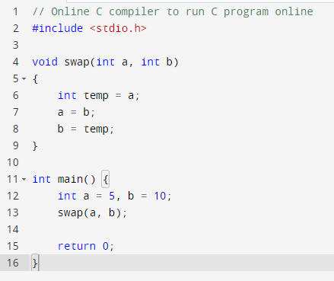

What's wrong with this code?

**It's pass by value so the variables are not swapped**

How can we fix it?

**Change it to pass by address**

Further questions on next page

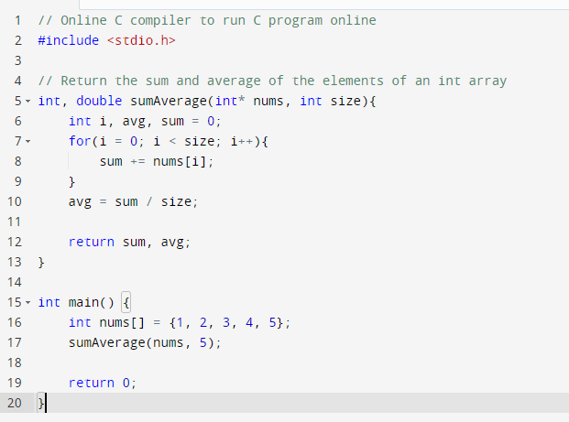

What's wrong with this code?

**Functions can't have multiple return types**

How can we fix it?

1. **Return only the sum, but perform the average calculation in the main function**
2. **Include the address of avg as a parameter and change it when you calculate the average in sumAverage**
3. **You could separate sumAverage into two different functions**